Vanier College Teachers’ Association
News Bulletin 7, November 7, 2014 

Negotiations
On Thursday, October 30, our demands were presented to the government. At each cegep, the local unions also presented an official letter to their local administrations.
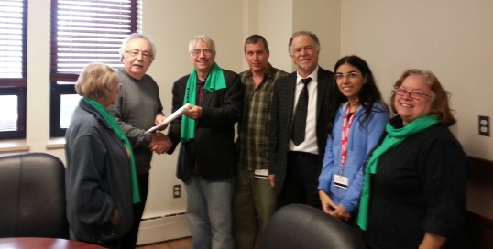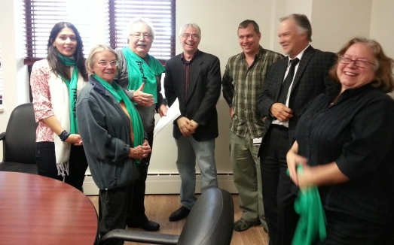
The VCTA and the AVCP (Professionals) present the letter to the Vanier administration.
Insurance
The changes to our Fneeq insurance have been accepted for TWO years beginning in January, 2015. Please be advised that if you are on school business (such as on a school trip), the College must provide insurance since our insurance plan does not cover you when you are on school business.
Salary Relativity: Don’t forget to fill out and hand in the card attached to the last bulletin. Let the government know that we want to be ranked at 24 because we are part of higher education
.

White Poppy Campaign
Wonder why some people are wearing the white poppy?
Come to the VCTA office and get a card that explains the
campaign. You can pick up a white poppy at the same time.
IRIS
The VCTA supports IRIS, a Quebec non-profit independent research institute founded in 2000, to counter the neo-liberal ideology which is presently so prevalent in our society. Because IRIS is concerned with education, the documents produced by the Institute are free of charge. Recently, IRIS has published two studies, one on domestic work and the other on whether unions are hurting Quebec, that may be of interest to many teachers. Here are the links to both:
http://iris-recherche.qc.ca/publications/taches-domestiques
http://iris-recherche.qc.ca/publications/syndicats

