

SPECIAL EDITION NEWSBULLETIN No. 9
April 3, 2008

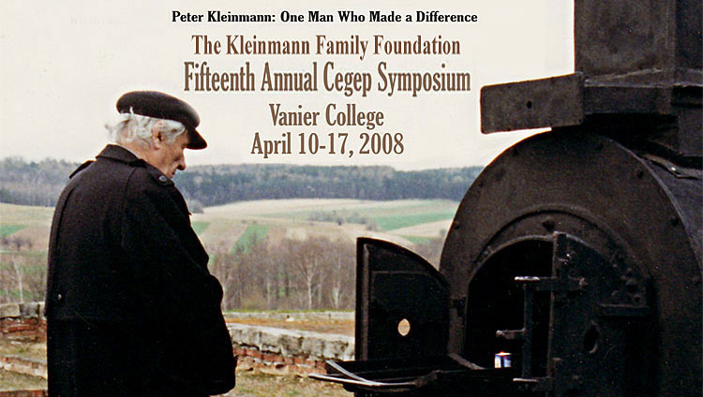

15th Annual Holocaust Symposium, April 10-17, 2008

Below please find the schedule for this year’s Kleinmann Family Foundation Holocaust Symposium at Vanier College. These events – survivor testimonies, lectures, films and discussions – are booked into ongoing courses by prior arrangement with the teachers concerned but are open to all (space permitting).

A special exhibit from the Jewish Museum in Prague, “Neighbours Who Disappeared”, will be displayed in the Library April 10 – May 2. Czech children and youth (ages 12-21) created mixed-media panels reflecting on the history of the Nazi Holocaust, as it affected their own cities and towns. The resulting collages combine text, drawings, paintings, contemporary and historical photographs, and facsimiles of historical documents.

The Czech connection is further developed during this year’s Symposium in the testimony of Terezin survivor Rudolph Roden (April 10) and the screening of the award-winning film, “Prisoner of Paradise,” with director Malcolm Clarke (April 14).

Another special feature will be the display in the Carrefour of a family memorial quilt created by renowned quilter, Helena Scheffer.

Finally, special mention should be made of American author Scott Benarde’s presentation on Tuesday April 15 on “The Holocaust as Reflected in Rock and Pop Music.”

Neil Caplan ….2

Thursday April 10
[various times] VCSA Film Screening, “Life Is Beautiful” (Auditorium)
11:30 Dr Rudolph Roden, survivor testimony (C305)
4:00 FILM: “The Pianist” (N568)

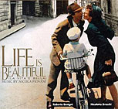

Friday April 11
10:00 Matthieu Sossoyan: The Swastika: Origins and Appropriation of a Symbol (Auditorium)
11:30 Musia Schwartz, survivor testimony (A342)
1:00 Musia Schwartz, survivor testimony (A306)

Monday April 14
8:00 Eva Kuper, child survivor testimony (B223)
10:00 FILM: “Undying Love” with director Helene Klodawsky (N573)
10:00 Sevak Manjikian, Media and Genocide (N375)
1:00 Ted Bolgar, survivor testimony (N431)
3:00 Martha Bernstein, French Youth During the Nazi Occupation (N529)

4:00 Ted Bolgar, survivor testimony (B223)
4:00 FILM: “The Pianist” (N516)
6:00 FILM: “Prisoner of Paradise” with director Malcolm Clarke (K322)

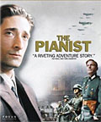

Tuesday April 15
11:30 Scott Benarde, The Holocaust as Reflected in Rock and Pop Music (B223)
12:00 Ted Bolgar, survivor testimony A314
1:00 FILM: “Once a Nazi…” with directors Frederic Bohbot & Evan Beloff (B223)
2:00 Tara Tavender, Save Darfur Canada (N201) video conference with Cegep de Sept-Isles
2:30 Jim Najarian & Neil Caplan, “Did it Really Happen? Genocide & Denial” (N231)
4:00 Eva Kuper, survivor testimony (N516)
4:00 Sevak Manjikian, Media and Genocide (N515)
4:00 Martha Bernstein, French Youth During the Nazi Occupation (N529)
6:00 Ted Bolgar, survivor testimony (A311)

Wednesday, April 16
8:30 FILM: “Once a Nazi…” with directors Frederic Bohbot & Evan Beloff (B223)
10:30 Eva Kuper, survivor testimony (B223)
10:30 FILM: “Paper Clips” (N562)
12:00 Oratorio Terezin Preview, with composer Ruth Fazal; memorial candle-lighting (Auditorium)
1:30 Bill Donat, survivor testimony: Rescue (D543)
3:00 Martha Bernstein, French Youth During the Nazi Occupation (N275)
3:30 Simon Wajcer, Faiga's Story (B223)

Thursday, April 17
8:00 Hope amid Despair: Amanda De Melo, “Girl in the Red Coat” & Erin Schachter, “Resistance through Art” (E509)
[various times] VCSA Film Screening, “Schindler’s List” (Auditorium)
10:00 Bill Donat, survivor testimony, Rescue (B223)
11:30 Hans Moeller, Danish Rescue (N375)
1:00 Bill Donat, survivor testimony: Rescue (N375)
1:00 FILM: “Paper Clips” (N416)
4:00 Simon Wajcer, Faiga's Story (N568)

The Symposium organizers are pleased to acknowledge the generous support and collaboration of the Burman-Wajcer Family Foundation, the VCSA, the VCTA and the Women’s Studies Program.

