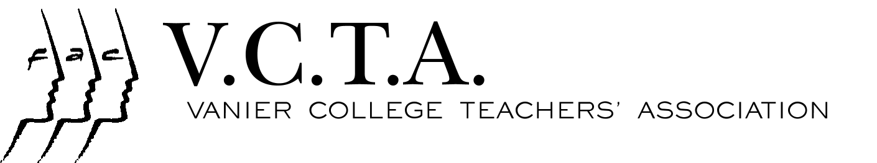

NEWSBULLETIN No. 6
November 28, 2007

Teaching at the College Level…Profile of the Profession

In the past week, all teachers should have received an e-mail from the college containing a document in PDF format. This document, referred to in the last VCTA News bulletin (Nov. 1, 2007) is entitled Teaching at the College Level…Portrait of the Profession. It is the draft of a final document, which will be produced by a parity committee, composed of representatives of college administrators and those of the three federations of college teachers. This committee has a mandate to examine the teaching profession, and such an examination could lead to a reevaluation of the parameters used to determine workloads and a possible reinvestment in college teaching. However, if any of this is to happen, it can only occur after the final copy of this document is produced in the spring of 2008.

The committee is currently seeking feedback on the document. They would like to know if what is described in it corresponds to your experience or if there are omissions or emendations to which you would like to draw attention. Among the subjects in it are the following: Programs, Departments, Teaching, Information and Communications Technologies; Professional Development, Research and Education; and Activities Related to Teaching Inside and Outside the College. The VCTA Executive and Association Council would like feedback from faculty on any of the subjects in the document that are of interest to them. Please come to the General Assembly at 2:00 pm on December 12th where this will be discussed.

DON’T FORGET – DECEMBER 12TH
General Assembly 2:00pm-4:30pm Happy Hour 4:30pm – 7:00pm

National Day of Remembrance and Action on Violence Against Women

On December 6, 1989 fourteen women were slain at the Polytechnique in Montreal. Join in a ceremony to honour their memory on Thursday December 6 at 2:30 in the Carrefour. Please encourage your students to attend. Other commemorative activities: Visit the display to mark this day in the Carrefour from November 26 to December 7. Find out more about violence in conjugal and dating relationships by visiting the information table mounted by Women’s Studies students on Wednesday December 5 during UB in the metro (between Jake’s Mall and the cafeteria). Make a contribution to a women’s shelter and receive a purple ribbon to wear as a sign of your commitment to ending this violence.

Organized by: The Women’s Studies Program and The Vanier Social Justice Committee

GOOD NEWS from Last Year!

Last year the VCTA negotiated changes in the availability policy for teachers. Because of the changes, teachers no longer have to provide a transfer of availability for the working days between Dec. 25th and Jan. 1st. We reproduce the policy below:

“6. The statutory holidays available to teaching personnel will be presented each spring at CRT for the upcoming academic year, and conform to the collective agreement and the Normes du Travail. Normally, Christmas day and New Year’s Day (or their substitutes, if the days fall on a weekend) will be the two statutory days given during the Christmas holiday period. However, a transfer of availability form will not be required for non-availability between December 25 and December 31. However, teachers will still be responsible for fulfilling their contractual obligations during that week, notably the submission of final grades”.

